**STEP: 1**

**Go to the chrome and open remix platform**

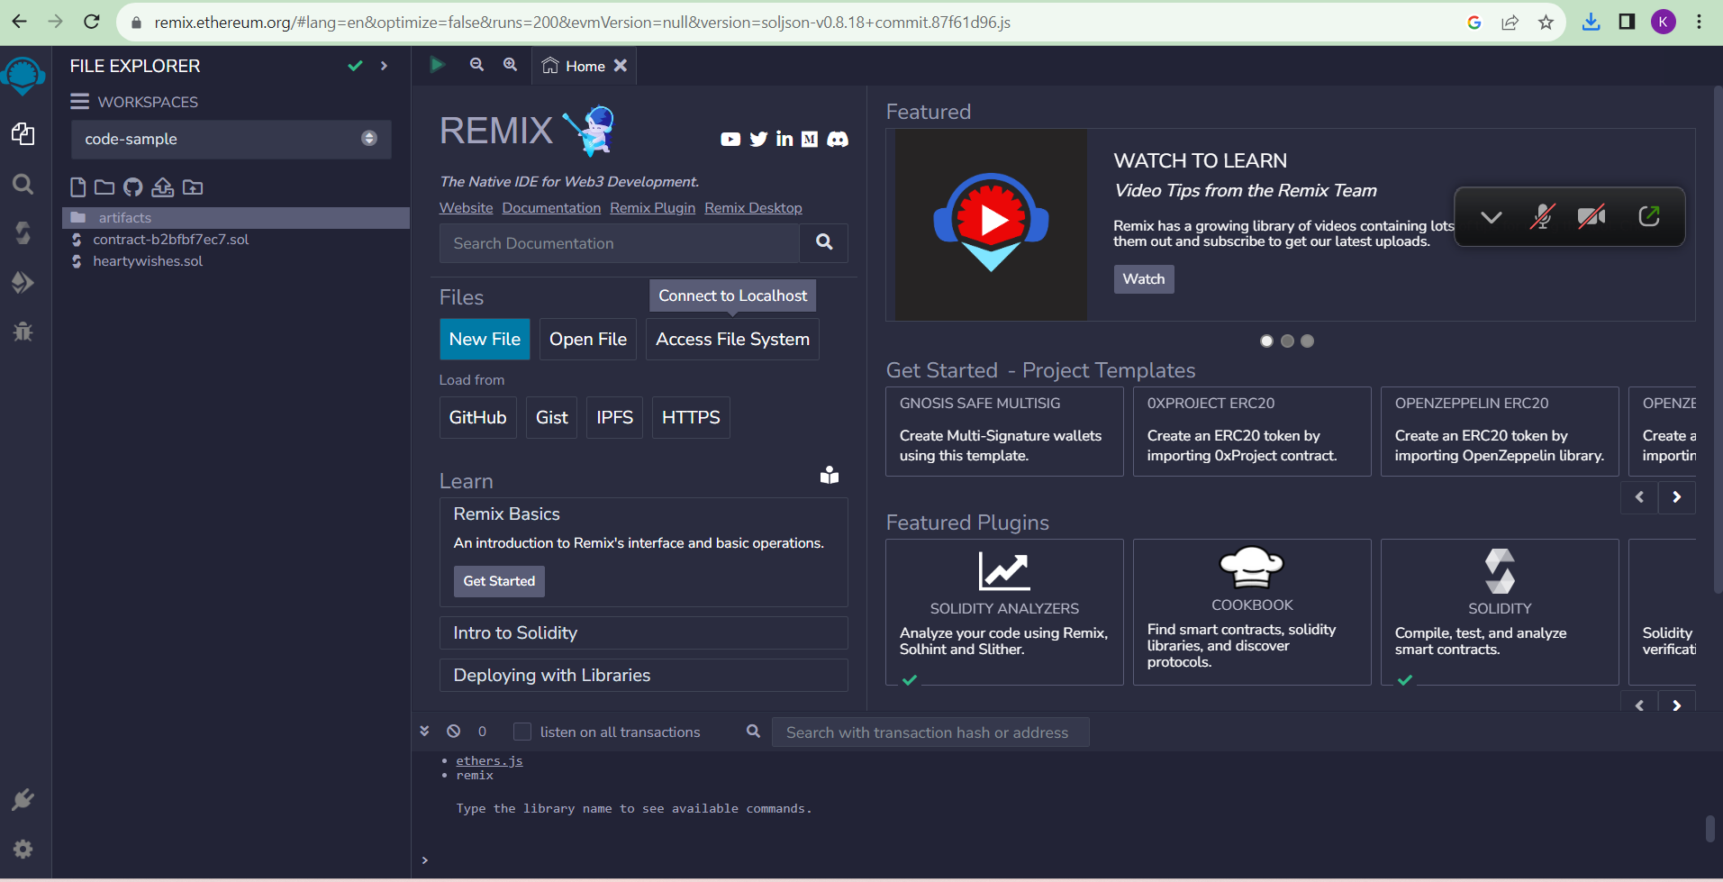

**STEP : 2**

**Open the remix page and create a new file**

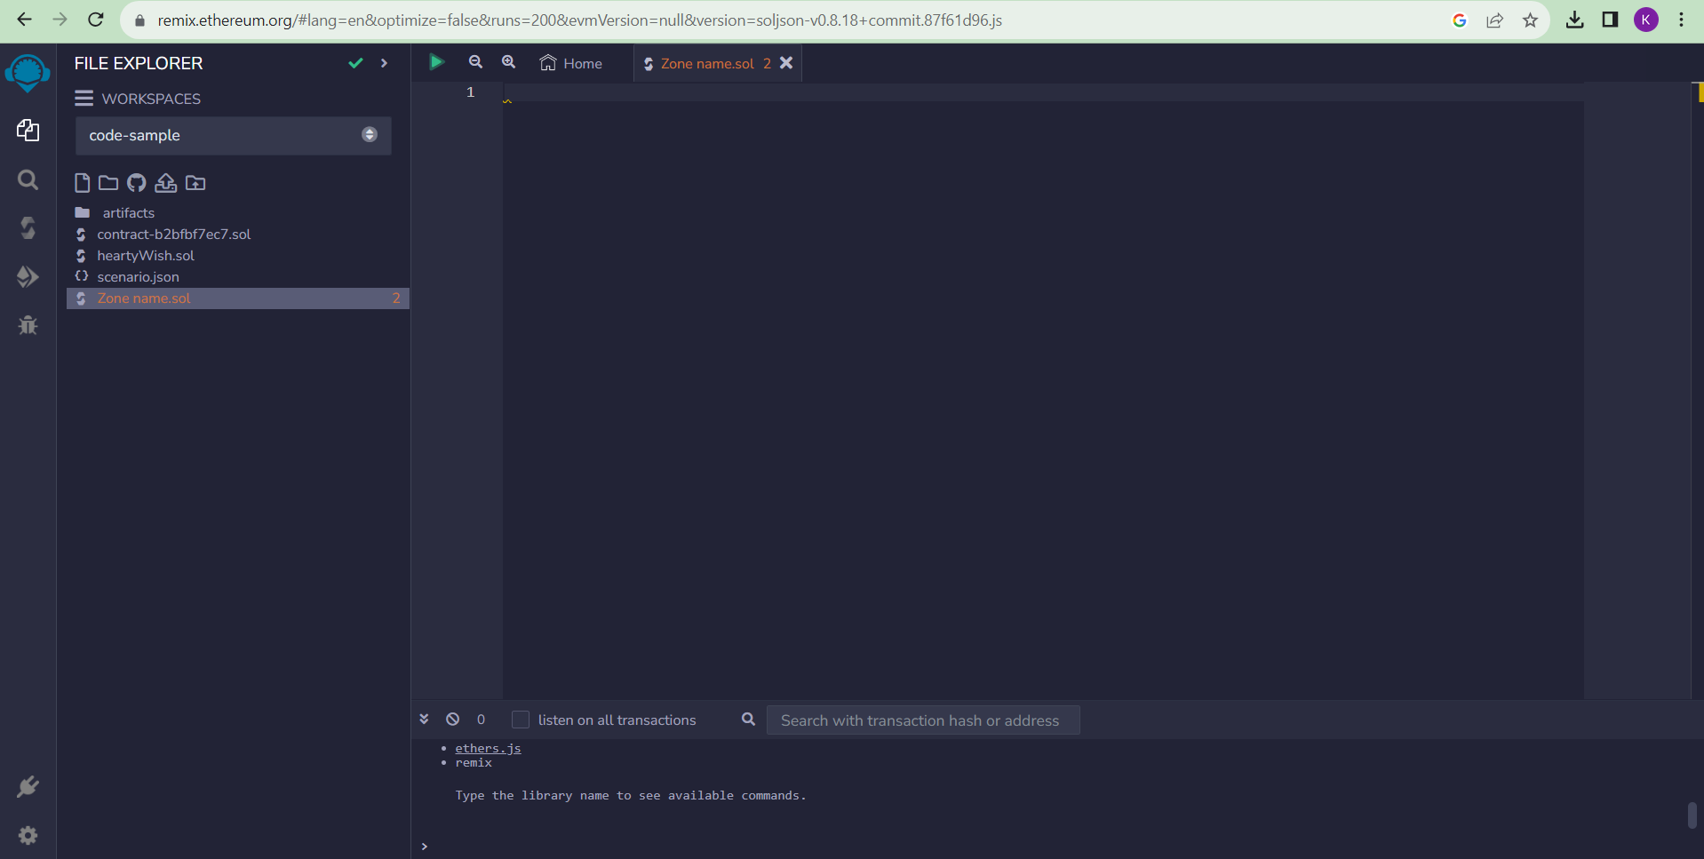

**STEP : 3**

**In that newly created file, create a program to return**

**your string,"Zone name"**

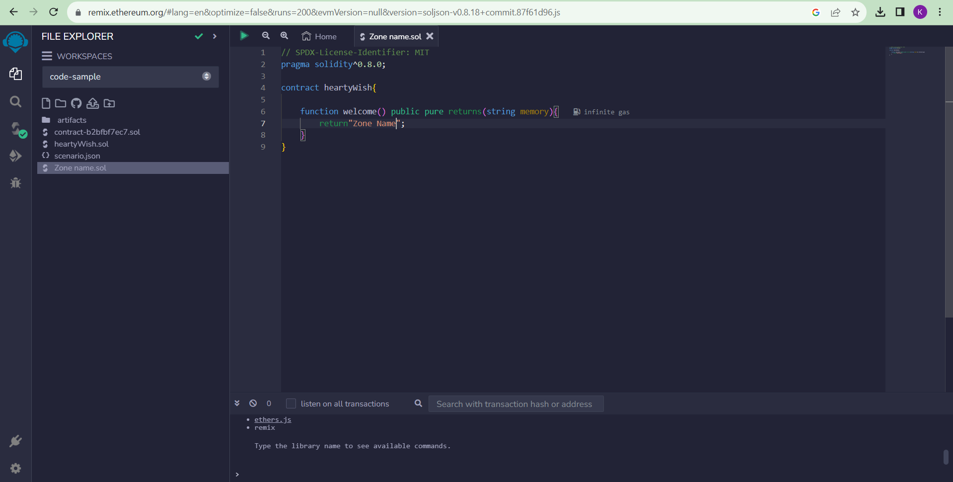

**STEP : 4**

**Save the program and compile it to get the ABI and Bytecode**

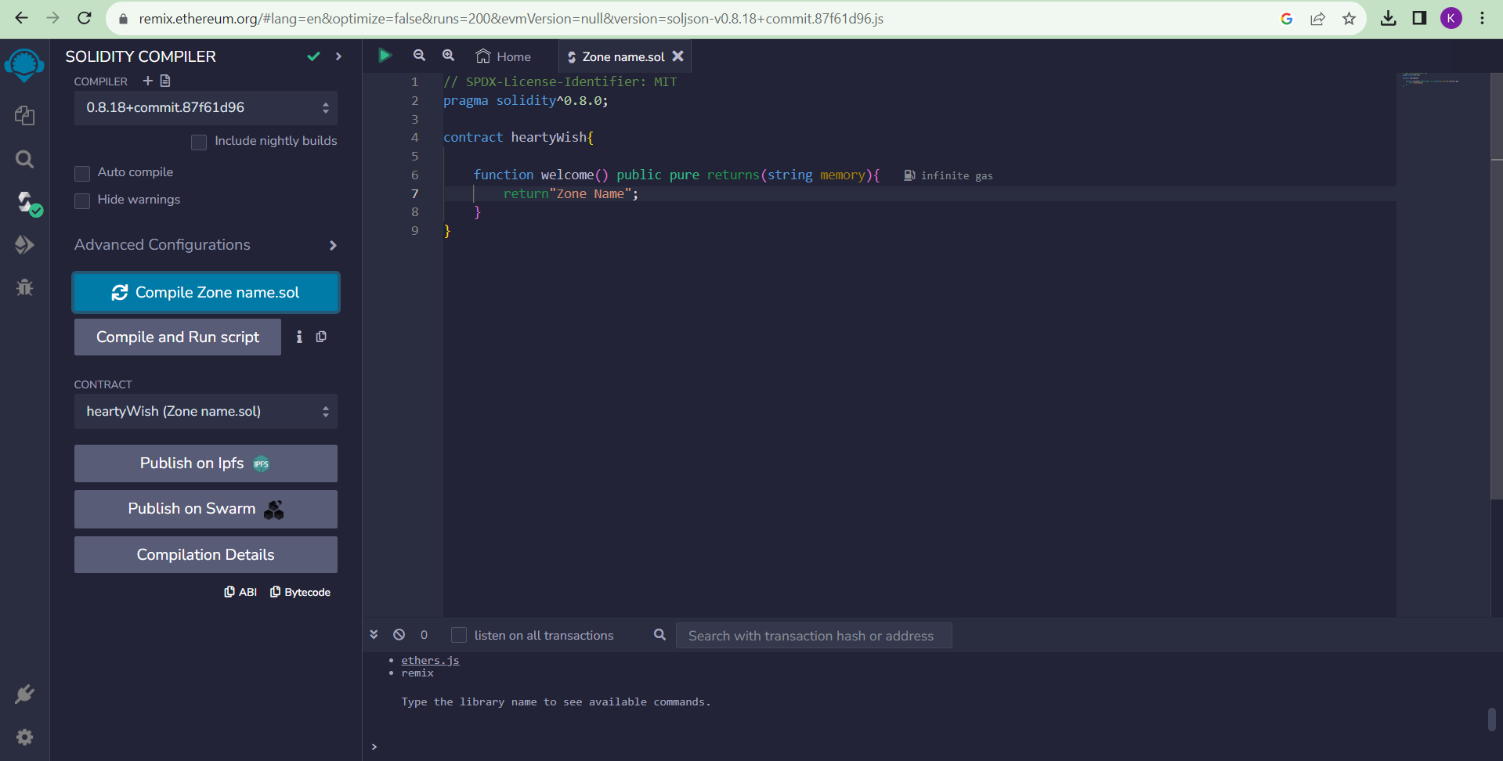

**ABI :**

**[**

**{**

**"inputs": [],**

**"name": "welcome",**

**"outputs": [**

**{**

**"internalType": "string",**

**"name": "",**

**"type": "string"**

**}**

**],**

**"stateMutability": "pure",**

**"type": "function"**

**}**

**]**

**BYTE CODE :**



**STEP 5 :**

**Finally Deploy it to display the output**

